Grove - Infrared temperature sensor

|  |
| --- |
| **Contents**   [[hide](javascript:toggleToc())]   * [1 Introduction](http://www.seeedstudio.com/wiki/Grove_-_Infrared_temperature_sensor#Introduction) * [2 Features](http://www.seeedstudio.com/wiki/Grove_-_Infrared_temperature_sensor#Features) * [3 Application Ideas](http://www.seeedstudio.com/wiki/Grove_-_Infrared_temperature_sensor#Application_Ideas) * [4 Specification](http://www.seeedstudio.com/wiki/Grove_-_Infrared_temperature_sensor#Specification) * [5 Usage](http://www.seeedstudio.com/wiki/Grove_-_Infrared_temperature_sensor#Usage) * [6 Version Tracker](http://www.seeedstudio.com/wiki/Grove_-_Infrared_temperature_sensor#Version_Tracker) * [7 Resources](http://www.seeedstudio.com/wiki/Grove_-_Infrared_temperature_sensor#Resources) * [8 Support](http://www.seeedstudio.com/wiki/Grove_-_Infrared_temperature_sensor#Support) |

Introduction

The Infrared temperature sensor is a non-contact temperature measure model. The sensor is composed of 116 elements of thermocouple in series on a floating micro-membrane,  the blacken surface to absorb the incident thermal infrared radiation, which induces a voltage response at output terminals. The sensor output a analog voltage(0~1.1V) according to target temperature.

[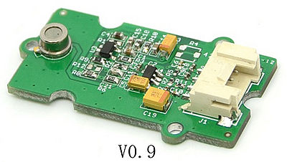](http://www.seeedstudio.com/wiki/File:Grove_-_Infrared_temperature_sensor.jpg)              [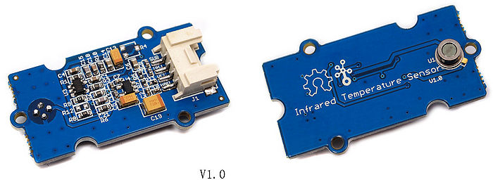](http://www.seeedstudio.com/wiki/File:Infrared_temperature_sensor_V1.0.jpg)

Features

* Grove compatible interface
* Zero drift amplify current
* Power consumption: less than 0.6mW
* Temperature measure range: -10~100 ℃
* Measure accuracy: ±2℃
* Nominal measure distance:9CM
* 2.0cm x 4.0cm Grove module

Application Ideas

* Motion sensor
* Thief-guarding System
* Switch
* Industrial automation
* Body distance check

Specification

|  |  |  |  |  |  |
| --- | --- | --- | --- | --- | --- |
| **Items** | **Conditions** | **Min** | **Type** | **Max** | **Unit** |
| VCC | - | 3 | - | 5 | Volts |
| Measuring Current Supply | VCC=3.3V | - | - | 200 | uA |
| VCC=5V | - | - | 160 | uA |
| Measuring Range | -10°C<temperature<100°;humidity<65% | -10 | - | 100 | °C |
| Holding Time | - | - | 2 | - | S |
| Operating Temperature | - | -10 | - | 80 | °C |
| Storge Temperature | - | -35 | - | 80 | °C |
| IO Structure | SUR,OBJ,VCC,GND | | | | |

Usage

The following sketch demonstrates a simple application of measure the measure the Surrounding temperature around the sensor and the temperature of the target which is in front of the sensor. And print the result on the serial monitor.

* Connect this module to seeeduino using [Grove-Base Shield](http://www.seeedstudio.com/depot/grove-base-shield-p-754.html?cPath=132) port A0 and A1.
* Connect Seeeduino to PC via a USB cable.
* Download the [File:Demo Code](http://www.seeedstudio.com/wiki/File:MeasureTemperature.zip) and open it.
* Upload the code, Please click [here](http://www.seeedstudio.com/wiki/Upload_Code) if you do not know how to upload.

Before measure temperature, You need simple setting. Following the instruction below before your test and you will gain a accurately result.   
**Step 1: Regulate the sensor voltage**  
After upload the demo program, make the sensor in normal environment more than 5 minutes that make the sensor temperature the same as surrounding temperature. Then open the serial monitor to check the voltage which the sensor output. Ideally, when the ambient temperature is equal to the temperature sensor, the infrared sensor (TP-538U) output is 0V.We should regulate the reference voltage which offset at 0.5V by hardware. As shown below, the sensor voltage is 0.014V, we just need to change the offset_vol value as0.014 which you obtain from the serial monitor in program.

[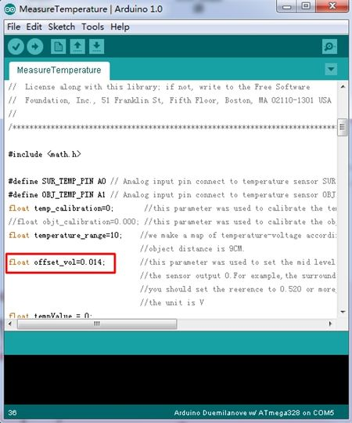](http://www.seeedstudio.com/wiki/File:Infrared_Temperature_Sensor_code2.jpg) [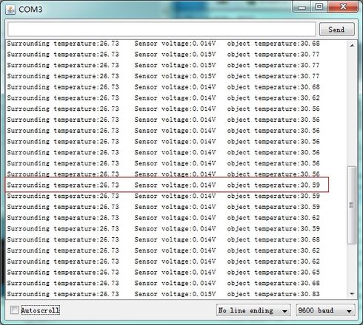](http://www.seeedstudio.com/wiki/File:Serialmonitor.jpg)

**Step 2:Regulate the sensor detected diatance**  
According to our experiment, the sensor nominal measure distance is 9CM, but we can’t ensure all sensor have the same character. So if you want to have accurately result, you need to regulate it with Ice and water mixture to measure the 0℃, and use boiled water to regulate the 100℃. After above you obtain the effective distance of the sensor.

The specific method for measuring is fill with ice and water in a dark container which have a flat surface. Waitting for the container drop to 0℃, keep the sensor 9CM between object, move the sensor forward or back and check the result, if output is 0℃, note down the distance value. The same method to check boiled water. When you gain a pair of value, make a deal with average calculation. You can begin to measure in a rated distance which you just obtained now.

Now we can measure the surrounding temperature around the sensor. The sensor is apply in a nominal distance, you can have a try in other distance, but the distance-temperature diagram neither sensor’s manufacturer nor we obtained, you can draw it follow the two instructions above. We reserve variable"temperature_range"in demo code. We assume that the target distance is 3 cm, the coefficient which you measured may be 5 more or less. Wish you have a fun try.

[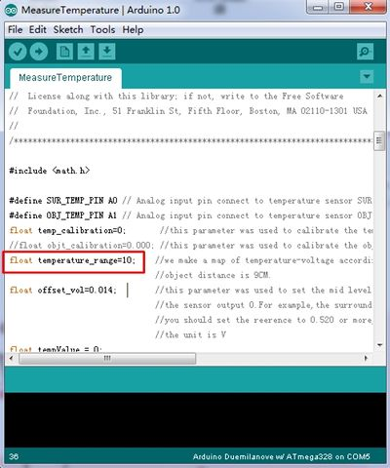](http://www.seeedstudio.com/wiki/File:Infrared_Temperature_Sensor_Code_1.jpg)

**Advanced application example:**

[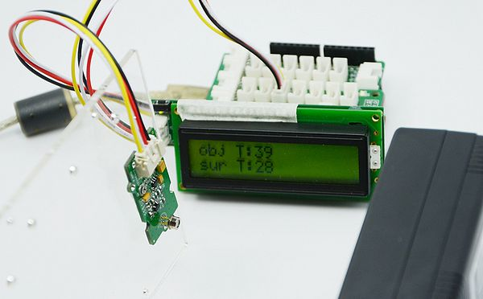](http://www.seeedstudio.com/wiki/File:Infrared_temperature_example.JPG)

**Note:**

1) The demo code does not support Atmega168.

2)In order to gain a accurate measured, the distance(D) and target diament(S) rate D:S must less than 0.5.

[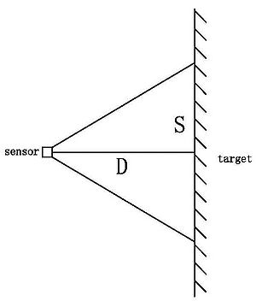](http://www.seeedstudio.com/wiki/File:Dsdiagram.jpg)

Version Tracker

|  |  |  |
| --- | --- | --- |
| **Revision** | **Descriptions** | **Release** |
| v0.92 | Initial public release | Jan 04, 2012 |
| v1.0 | Change the sensor position(on the other side),change board silk. | Feb 14, 2012 |

Resources

* [Grove-Infrared Temperature Sensor V0.9 Egale File](http://www.seeedstudio.com/wiki/File:Infrared_Temperature_Sensor_v0.92_egale_file.zip)
* [Grove-Infrared Temperature Sensor V1.0 Egale File](http://www.seeedstudio.com/wiki/File:Infrared_Temperature_Sensor_V1.0_egale_file.zip)
* [OTP-538Udatasheet](http://www.seeedstudio.com/wiki/File:OTP-538Udatasheet.zip)
* [Demo Code](http://www.seeedstudio.com/wiki/File:MeasureTemperature.zip)
* [Infrared Temperature Demo Code with SerialLCD.zip](http://www.seeedstudio.com/wiki/File:Infrared_temperature_demo_code_with_serialLCD.zip)]